1)Syllabus :
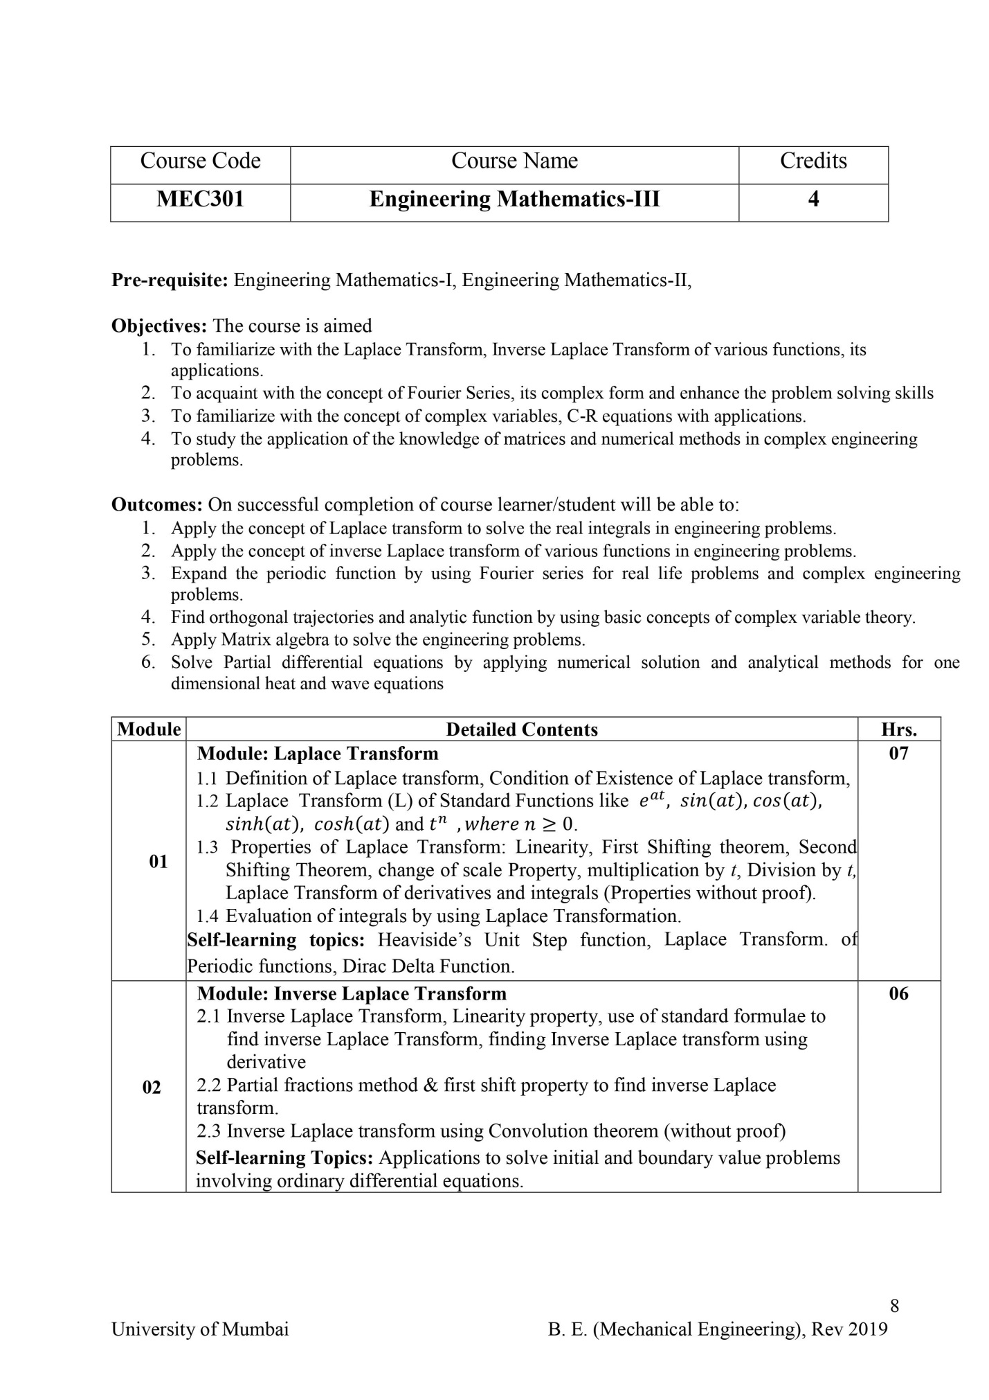
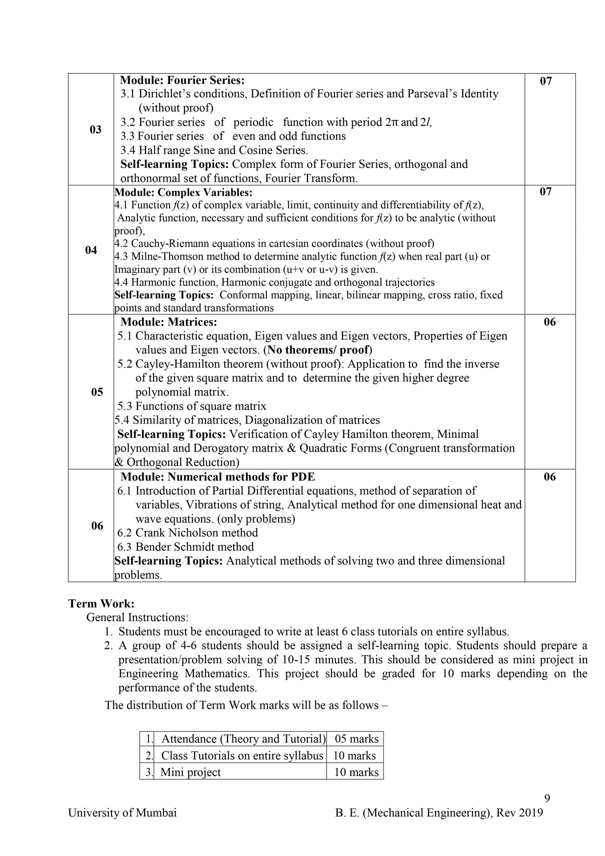
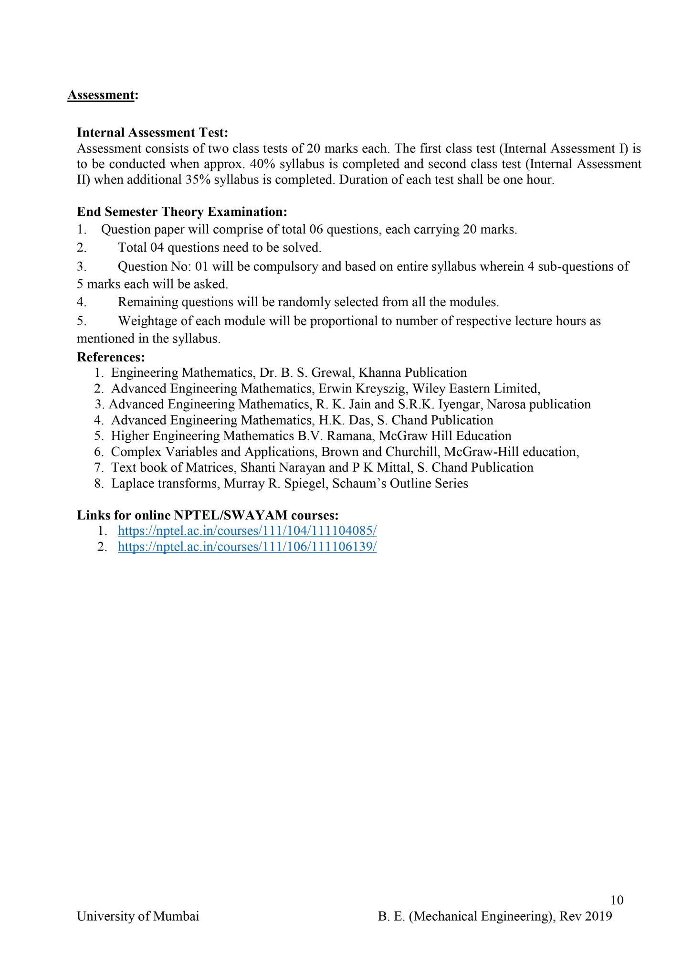2) LECTURE PLAN:

Course & Branch | S.E.PRODUCTION/MECHANICAL | Current Semester | III
Academic Year | 2020 – 21 : JULY-DEC : 2020 | Contact Hours | 04 hours per week
Teacher In-charge: Prof. Sundary S.Prabavathy

Sr. No. | Name of the Topic | Planned Date  D/M/Y | Executed Date  D/M/Y | Module/Remark
1 | Introduction to basic Calculus & other prerequisites | 11/07/2020 | 11/07/2020 | M-1
2 | Introduction to Laplace Transform | 15/07/2020 | 15/07/2020
3 | Definition &formulae for L.T of standard functions | 19/07/2020 | 19/07/2020
4 | Properties of L.T | 21/07/2020 | 21/07/2020
5 | Problems on Standard functions &First Shifting | 23/07/2020 | 23/07/2020
6 | ……………Multiplication by t &powers of t(>0) | 26/07/2020 | 26/07/2020
7 | ……………Division by t | 28/07/2020 | 28/09/2020
8 | ……………Change of scale &Second Shifting | 30/07/2020 | 30/07/2020
9 | Evaluation of real integrals using L.T | 31/07/2020 | 31/07/2020
10 | Determining unknown constant in integrand using L.T | 01/08/2020 | 01/08/2020
11 | TUTORIAL 1 : L.T | 03/08/2020 | 03/08/2020
12 | Inverse L.T: Definition &problems on Standard functions | 04/08/2020 | 04/08/2020 | M-2
13 | Problems using Partial Fractions | 05/08/2020 | 05/08/2020
14 | ………………First Shifting | 07/08/2020 | 07/08/2020
15 | ……………………………&Partial fractions combined | 10/08/2020 | 10/08/2020
16 | ……………….Convolution Theorem | 11/08/2020 | 11/08/2020
17 | -------------------------------------------continued | 13/08/2020 | 13/08/2020
18 | ……………………………..&First Shifting combined | 14/08/2020 | 14/08/2020
19 | ………………derivatives of F(s) for special cases | 17/08/2020 | 17/08/2020
20 | TUTORIAL 2 : Inverse L.T | 18/08/2020 | 17/08/2020 | 2pm-3pm
21 | Fourier Series :Introduction& important formulae | 20/08/2020 | 20/08/2020 | M-3
22 | F.S expansion for f(x) defined in (0 , 2pi ) | 21/08/2020 | 21/08/2020
23 | -----------------------------------------(0 , 2l ) | 22/08/2020 | 22/08/2020
24 | ----------------------------------------( - pi , pi )odd, even&general | 24/08/2020 | 24/08/2020 | UT 1:27-29
25 | ----------------------------------------( - l , l )---------------------- | 31/08/2020 | 31/08/2020
26 | Half Range Sine series | 01/09/2020 | 01/09/2020
27 | Half Range Cosine series | 01/09/2020 | 02/09/2020
28 | TUTORIAL : 3: F.S | 02/09/2020 | 02/09/2020 | 2pm – 3pm
29 | Complex Variables(Introduction) | 03/09/2020 | 03/09/2020 | M-4
30 | Definitions: Analytic, Harmonic, Regular function ,theorems | 07/09/2020 | 07/09/2020
31 | Problems on Constructions of analytic functions :given :u | 08/09/2020 | 08/09/2020
32 | ………………………………………………….:given :v | 10/09/2020 | 10/09/2020 | Holidays 11-16
33 | ……………………………………. :given : u+v | 17/09/2020 | 17/09/2020
34 | --------------------------------------------------------- :given : u - v | 18/09/2020 | 18/09/2020
35 | ……….proving f(z) is constant given 2 conditions | 25/09/2020 | 25/09/2020
36 | ………….finding second order derivatives of given functions | 28/09/2020 | 28/09/2020
37 | ---------------------harmonic conjugate | 29/09/2020 | 29/09/2020
38 | --------------------Orthogonal Trajectories | 30/09/2020 | 30/09/2020
39 | ---------to verify :given function is harmonic or not | 01/10/2020 | 01/10/2020
40 | TUTORIAL : 4 :C.V | 03/10/2020 | 03/10/2020
41 | Matrices:: Definitions: Characteristic equation ,roots &vectors | 05/10/2020 | 05/10/2020 | M-5
42 | Cayley Hamilton Theorem Statement &application 1 (inverse) | 06/10/2020 | 06/10/2020
43 | C.H.T: Application :Reduction of higher degree polynomial | 08/10/2020 | 08/10/2020
44 | Problems :Eigen values &properties | 09/10/2020 | 09/10/2020
45 | Functions of square matrices | 15/10/2020 | 15/10/2020
46 | Eigen vectors: Definition ,properties &problems | 16/10/2020 | 16/10/2020
47 | ------------------Problems continued | 19/10/2020 | 19/10/2020
48 | Similar matrices, Algebraic & Geometric Multiplicity | 20/10/2020 | 20/10/2020
49 | Diagonalization of matrices :Definitions :Modal matrix | 22/10/2020 | 22/10/2020
50 | ---------------------------------:Problems | 23/10/2020 | 22/10/2020
51 | --------------------------------Problems continued | 26/10/2020 | 26/10/2020
52 | TUTORIAL : 5 : Matrices | 27/10/2020 | 27/10/2020
53 | Partial Differential Equations :Introduction | 29/10/2020 | 29/10/2020 | M-6
54 | Numerical methods :Bender’s for solving P.D.E | 02/11/2020 | 02/11/2020
55 | …………………...:Nicholson’s ………………… | 03/11/2020 | 03/11/2020
56 | Analytical method :One dimensional heat equation | 05/11/2020 | 05/11/2020
57 | …………………..: …………………wave………. | 06/11/2020 | 09/11/2020
58 | Special problems on heat &wave equations(analytical) | 09/11/2020 | 09/11/2020
59 | TUTORIAL : 6: P.D.E | 10/11/2020 | 11/11/2020
60 | Re-tutorials for missed out students | 11/11/2020 | 11/11/2020 | 2 pm-4pm
61 | Mini Project : Discussion on self- study topics :Modules 1&2 | 19/11/2020 | 19/11/2020
62 | --------------------------------------------Modules 3&4 | 20/11/2020 | 20/11/2020
63 | ------------------------------------------- Module 5&6 | 22/11/2020 | 22/11/2020 | UT 2:27-29
Signature : Sundary S.Prabavathy
Date : 22 / 11 / 2020.

3)COURSE OUTCOMES :

Upon completion of this course students will be able to
PEC/MEC 301 1: evaluate real integrals using Laplace Transform
PEC/MEC 301.2: find the inverse Laplace Transform of given function
(if it exists)
PEC/MEC 301.3: express periodic functions in Fourier series
PEC/MEC 301.4: construct analytic function &also obtain the orthogonal
Trajectories of the given family of curves
PEC/MEC 301.5: diagonalize the given matrix (if diagonalizable)&apply Cayley
Hamilton theorem
PEC/MEC 301.6: solve one dimensional heat &wave equation
-------------------------------------------------------------------------------------------------------------

4)CO Assessment Tools:

PEC/MEC 301.1: Direct Methods (80%): Test 1+Tutorial 1+ End Exam
CO1 dm = 0.4 x test 1+0.2 x tutorial 1 + 0.4 x end exam
Indirect Methods (20%): Course Exit Survey (CES)
CO1 idm =1x CES
PEC/MEC 301.1 = (0.8 x CO1 dm) + (0.2 x CO1 idm)
---------------------------------------------------------------------------------------------------------------------
PEC/MEC 301.2: Direct Methods (80%): Test 1+Tutorial 2+ End Exam
CO2 dm = 0.4 x test1+0.2 x tutorial 2+0.4 x end exam
Indirect Methods (20%): Course Exit Survey (CES)
CO2 idm =1x CES
PEC/MEC 301.2 = (0.8 x CO2 dm) + (0.2 x CO2 idm)
---------------------------------------------------------------------------------------------------------------------
PEC/MEC 301.3: Direct Methods (80%): Test 2+Tutorial 3 + End Exam
CO3 dm = 0.4 x test 2 + 0.2 x tutorial 3+0.4 x end exam
Indirect Methods (20%): Course Exit Survey (CES)
CO3 idm =1x CES
PEC/MEC 301.3 = (0.8 x CO3 dm) + (0.2 x CO3 idm)
---------------------------------------------------------------------------------------------------------------------
PEC/MEC 301.4: Direct Methods (80%): Test 2 +Tutorial 4+ End Exam
CO4 dm =0.4 x test 2 + 0.2 x tutorial 4 + 0.4 x end exam
Indirect Methods (20%): Course Exit Survey (CES)
CO4 idm =1x CES
PEC/MEC 301.4 = (0.8 x CO4 dm) + (0.2 x CO4 idm)
---------------------------------------------------------------------------------------------------------------------
PEC/MEC 301.5: Direct Methods (80%): Tutorial 5+ End Exam
CO5dm = 0.4 x tutorial 5 + 0.6 x end exam

Indirect Methods (20%): Course Exit Survey (CES)
CO5 idm =1x CES
PEC/MEC 301.5 = (0.8 x CO5 dm) + (0.2x CO5 idm)
---------------------------------------------------------------------------------------------------------------------
PEC/MEC 301.6: Direct Methods (80%): Tutorial 6 + End Exam
CO6dm = 0.4 x tutorial 6 + 0.6 x end exam

Indirect Methods (20%): Course Exit Survey (CES)
CO6 idm =1x CES
PEC/MEC 301.6 = (0.8 x CO6 dm) + (0.2 x CO6 idm)

5) CO – PO MAPPING :

CO | PO1
PEC/MEC301.1 | 2
PEC/MEC301.2 | 2
PEC/MEC301.3 | 2
PEC/MEC301.4 | 2
PEC/MEC301.5 | 2
PEC/MEC301.6 | 3
TOTAL | 13
Direct Attainment | 2.25 (M)

Justification:
Above CO’s are mapped to the following PO’s as explained below:
PO1: provide the complete basic mathematical knowledge required for
- evaluating real integrals using Laplace Transform
- evaluating inverse Laplace transform of the standard functions.
- expressing periodic functions as Fourier and half-range series.
- constructing analytic functions &obtaining orthogonal trajectories
- diagonalzing matrix
- solving Heat &Wave equations

6)Course Outcomes Target:

PEC/MEC 301.1
TARGET RANGE: 2.5

PEC/MEC 301.2
TARGET RANGE: 2.5

PEC/MEC 301.3.
TARGET RANGE: 2.5

PEC/MEC 301.4
TARGET RANGE: 2.5

PEC/MEC 301.5
TARGET RANGE: 2.5

PEC/MEC 301.6
TARGET RANGE: 2.5

