Lesson plan
Subject: | Mechanics of Solids
Academic Year: | 2019-20
Name of the Teacher: | Mrs. Deepika Singh Singraur
Class | S. E. Production
Credits | 04

- Syllabus.
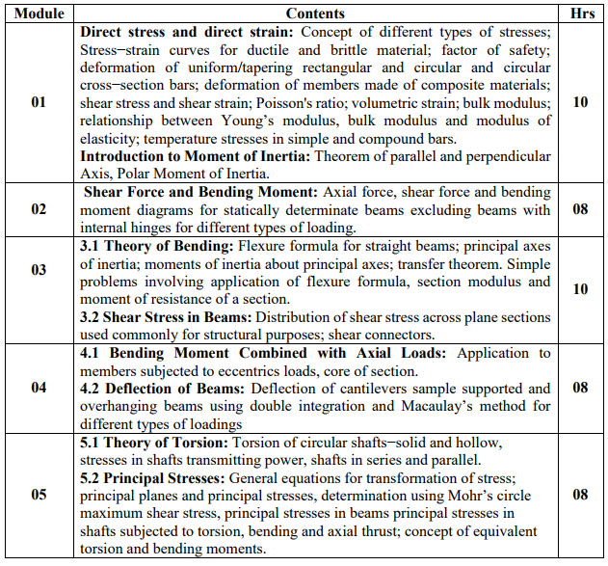
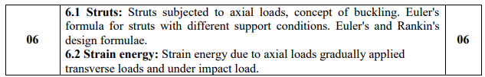

- CO Statements.
Learner will be able to...
1. Illustrate stress-strain behavior of various materials under load
2. Demonstrate the basic concepts related to material properties and stress strain behavior of material.
3. Illustrate the basic concept of Bending moment and Shear force
4. Develop skills to analyze the stresses and deformation due to axial loading.
5. Illustrate basic concepts of bending, torsion, buckling, deflection and strain energy
6. Develop skills to visualize with analysis of stresses under various loading conditions.

3. CO-PO-PSO Mapping.

CO# / PO# | PO1 | PO2 | PO3 | PO4 | PO5 | PO6 | PO7 | PO8 | PO9 | PO10 | PO11 | PO12
PEC305.1 | 3 | 3 | 2 | - | - | - | - | - | - | - | - | -
PEC305.2 | 3 | 3 | 2 | - | - | - | - | - | - | - | - | -
PEC305.3 | 3 | 3 | 2 | - | - | - | - | - | - | - | - | -
PEC305.4 | 3 | 3 | 2 | - | - | - | - | - | - | - | - | -
PEC305.5 | 3 | 3 | 2 | - | - | - | - | - | - | - | - | -
PEC305.6 | 3 | 3 | 2

CO# / PSO# | PSO1 | PSO2
PEC305.1 | - | -
PEC305.2 | - | -
PEC305.3 | - | -
PEC305.4 | - | -
PEC305.5 | - | -
PEC305.6 | - | -

4. CO Assessment tools with target.

Co Statement # | Target for Assessment Tools
 | Unit Test | End Semester Exam | Course Exit Survey
PEC305.1 | 50% | 50% | 60%
PEC305.2 | 50% | 50% | 60%
PEC305.3 | 50% | 50% | 60%
PEC305.4 | 50% | 50% | 60%
PEC305.5 | 50% | 50% | 60%
PEC305.6 | 50% | 50% | 60%

5. Curriculum Gap/Content beyond syllabus (if any).

---------------------

6. Lecture/Lab/Mini Project/Assignment Plan.

 | Topics Covered | Topics Planned | Module | Hours
Week1  (1.07.19 - 7.07.19) | Direct stress and direct strain: Concept of different types of stresses; Stress−strain curves for ductile and brittle material  Factor of safety;  Poisson's ratio; volumetric strain; bulk modulus; relationship between Young’s modulus, bulk modulus and modulus of elasticity.  Extra topics covered: Strain Hardening, Concept of Fatigue and creep, cyclic loading, Material properties. | Direct stress and direct strain: Concept of different types of stresses; Stress−strain curves for ductile and brittle material  Factor of safety; deformation of uniform/tapering rectangular and circular and circular cross−section bars; deformation of members made of composite materials; shear stress and shear strain  Poisson's ratio; volumetric strain; bulk modulus; relationship between Young’s modulus, bulk modulus and modulus of elasticity | 1 | 3
Week 2  (8.07.19 - 14.07.19) | Deformation of uniform/tapering rectangular and circular and circular cross−section bars; deformation of members made of composite materials; shear stress and shear strain | Temperature stresses in simple and compound bars. | 1 | 4
Week 3  (15.07.19 - 21.07.19) | Different types of beams, loading, support reactions and different types of loads. Numerical on simply supported beam on shear force and bending moment | 2.1 Shear Force and Bending Moment: Axial force, shear force and bending moment diagrams for statically determinate beams excluding beams with internal hinges for different types of loading. | 2 | 4
Week 4  (22.07.19 - 28.07.19) | Concept of shear force and bending moment diagram for cantilever beam. Point of contra flexure. | 2.1 Shear Force and Bending Moment: Axial force, shear force and bending moment diagrams for statically determinate beams excluding beams with internal hinges for different types of loading. | 2 | 4
Week 5  (29.07.19 – 04.08.19) | Numericals on SFD and BMD, Moment of Inertia | Introduction to Moment of Inertia.  Introduction to centre of gravity and parallel axis theorem and perpendicular Axis, Polar Moment of Inertia. | 2 | 4
Week 6  (05.08.19 - 11.08.19) |  | 5.1 Theory of Torsion: Torsion of circular shafts−solid and hollow, stresses in shafts transmitting power | 5 | 4
Week 7  (12.08.19 - 18.08.19) |  | Unit Test 1 SE, TE.
Week 8  (19.08.19 - 25.08.19) |  | 5.1 Shafts in series and parallel.  5.2 Concept of equivalent torsion and bending moments. | 5 | 4
Week 9  (26.08.19 - 01.09.19) |  | 5.2 Principal Stresses: General equations for transformation of stress  5.2 Principal planes and principal stresses 5.2 Determination using Mohr’s circle maximum shear stress,  Principal stresses in beams principal stresses in shafts subjected to torsion, bending and axial thrust | 5 | 4
Week 10  (09.09.19 - 15.09.19) |  | 6.1 Struts: Struts subjected to axial loads, concept of buckling. Euler's formula for struts with different support conditions.  Euler's and Rankin's design  6.2 Strain energy: Strain energy due to axial loads gradually applied transverse loads and under impact load.  Formulae. | 6 | 4
Week 11  (16.09.19 - 22.09.19) |  | 3.1 Theory of Bending: Flexure formula for straight beams; principal axes of inertia; moments of inertia about principal axes; transfer theorem.  3.1 Theory of Bending: Flexure formula for straight beams; principal axes of inertia; moments of inertia about principal axes; transfer theorem. | 3 | 4
Week 12  (23.09.19 - 29.09.19) |  | 3.1 Numerical on application of flexure formula, section modulus and moment of resistance of a section.  3.2 Shear Stress in Beams: Distribution of shear stress across plane sections used commonly for structural purposes; shear connectors. | 3 | 2
Week 13  (30.09.19 - 06.10.19) |  | 4.1 Bending Moment Combined with Axial Loads: Application to members subjected to eccentrics loads, core of section. | 4 | 4
Week 14  (07.10.19 - 13.10.19) |  | 4.2 Deflection of Beams: Deflection of cantilevers sample supported and overhanging beams using double integration and Macaulay’s method for different types of loadings | 4 | 4
Week 15  (14.10.19 - 20.10.19) |  | Unit Test 2 SE, TE.
Week 16 |  | Term End

