Lesson plan
Subject: | Manufacturing Engineering I
Academic Year: | 2019-20
Name of the Teacher: | Mrs. Deepika Singh Singraur
Class | S. E. Production
Credits | 04

- Syllabus.

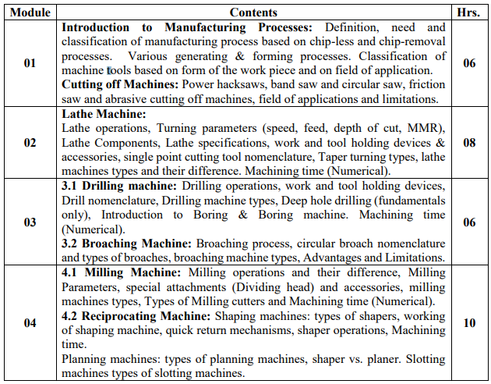
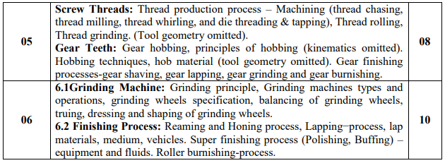

- CO Statements.
Learner will be able to...
1. Describe types of machine tools, their classification, specifications and constructional features
2. Illustrate machine tools capabilities, limitations of machining operations to generate cylindrical, circular and planar components
3. Demonstrate different kinds of cutting tools with their significance of work-piece interface.
4. Describe features and applications of screw thread processes.
5. Describe features and applications of gear manufacturing processes.
6. Demonstrate finishing processes like grinding, reaming, honing, lapping and burnishing.

3. CO-PO-PSO Mapping.

CO# / PO# | PO1 | PO2 | PO3 | PO4 | PO5 | PO6 | PO7 | PO8 | PO9 | PO10 | PO11 | PO12
PEC305.1 | 3 | 3 | 2 | - | - | - | - | - | - | - | - | -
PEC305.2 | 3 | 3 | 2 | - | - | - | - | - | - | - | - | -
PEC305.3 | 3 | 3 | 2 | - | - | - | - | - | - | - | - | -
PEC305.4 | 3 | 3 | 2 | - | - | - | - | - | - | - | - | -
PEC305.5 | 3 | 3 | 2 | - | - | - | - | - | - | - | - | -
PEC305.6 | 3 | 3 | 2

CO# / PSO# | PSO1 | PSO2
PEC305.1 | - | -
PEC305.2 | - | -
PEC305.3 | - | -
PEC305.4 | - | -
PEC305.5 | - | -
PEC305.6 | - | -

4. CO Assessment tools with target.

Co Statement # | Target for Assessment Tools
 | Unit Test | End Semester Exam | Course Exit Survey
PEC305.1 | 50% | 50% | 60%
PEC305.2 | 50% | 50% | 60%
PEC305.3 | 50% | 50% | 60%
PEC305.4 | 50% | 50% | 60%
PEC305.5 | 50% | 50% | 60%
PEC305.6 | 50% | 50% | 60%

5. Curriculum Gap/Content beyond syllabus (if any).

---------------------

6. Lecture/Lab/Mini Project/Assignment Plan.

 | Topics Covered | Topics Planned | Module | Hours
Week1  (1.07.19 - 7.07.19) | Introduction to Manufacturing Processes:  Definition, need and classification of manufacturing process  Chip-less and chip-removal processes. | 1.1 Introduction to Manufacturing Processes:  Definition, need and classification of manufacturing process  Chip-less and chip-removal processes. | 1 | 2
Week 2  (8.07.19 - 14.07.19) | Various generating & forming processes. | Various generating & forming processes.  Classification of machine tools based on form of the work piece and on field of application. | 1 | 2
Week 3  (15.07.19 - 21.07.19) | Nomenclature of single point and multi point cutting tool, tool signature | Classification of machine tools based on form of the work piece and on field of application. | 1 | 2
Week 4  (22.07.19 - 28.07.19) | Cutting tool material, factors selected for selection of cutting tool, cutting fluids and selection | 2.1 Cutting off Machines: Power hacksaws, band saw and circular saw, friction saw and abrasive cutting off machines, field of applications and limitations. | 1 | 2
Week 5  (29.07.19 – 04.08.19) | 2.1 Cutting off Machines: Power hacksaws, band saw and circular saw, friction saw and abrasive cutting off machines, field of applications and limitations. | 3.1 Drilling machine: Drilling operations, work and tool holding devices | 3 | 2
Week 6  (05.08.19 - 11.08.19) | 3.1 Drilling machine: Drilling operations, work and tool holding devices | Drill nomenclature, Drilling machine types | 3 | 2
Week 7  (12.08.19 - 18.08.19) |  | Unit Test 1 SE, TE.
Week 8  (19.08.19 - 25.08.19) |  | Deep hole drilling (fundamentals only), Introduction to Boring & Boring machine. Machining time (Numerical). | 3 | 2
Week 9  (26.08.19 - 01.09.19) |  | 3.2 Broaching Machine: Broaching process, circular broach nomenclature and types of broaches | 3 | 2
Week 10  (09.09.19 - 15.09.19) |  | Broaching machine types, Advantages and Limitations. | 3 | 1
Week 11  (16.09.19 - 22.09.19) |  | 6.1Grinding Machine: Grinding principle, Grinding machines types and operations | 6 | 2
Week 12  (23.09.19 - 29.09.19) |  | Grinding wheels specification, balancing of grinding wheels, truing, dressing and shaping of grinding wheels. | 6 | 2
Week 13  (30.09.19 - 06.10.19) |  | 6.2 Finishing Process: Reaming and Honing process, Lapping−process, lap materials, medium, vehicles. | 6 | 2
Week 14  (07.10.19 - 13.10.19) |  | Super finishing process (Polishing, Buffing) – equipment and fluids. Roller burnishing-process. | 6 | 2
Week 15  (14.10.19 - 20.10.19) |  | Unit Test 2 SE, TE.
Week 16 |  | Term End

