Credits-04
S.E. (Production) (semester IV) (2019-2020) Lecture Plan
Subject: Dynamics of Machines (DOM-PEC402)
FR. Conceicao Rodrigues College Of Engineering
Father Agnel Ashram, Bandstand, Bandra-west, Mumbai-50
Department of Production Engineering

Syllabus.

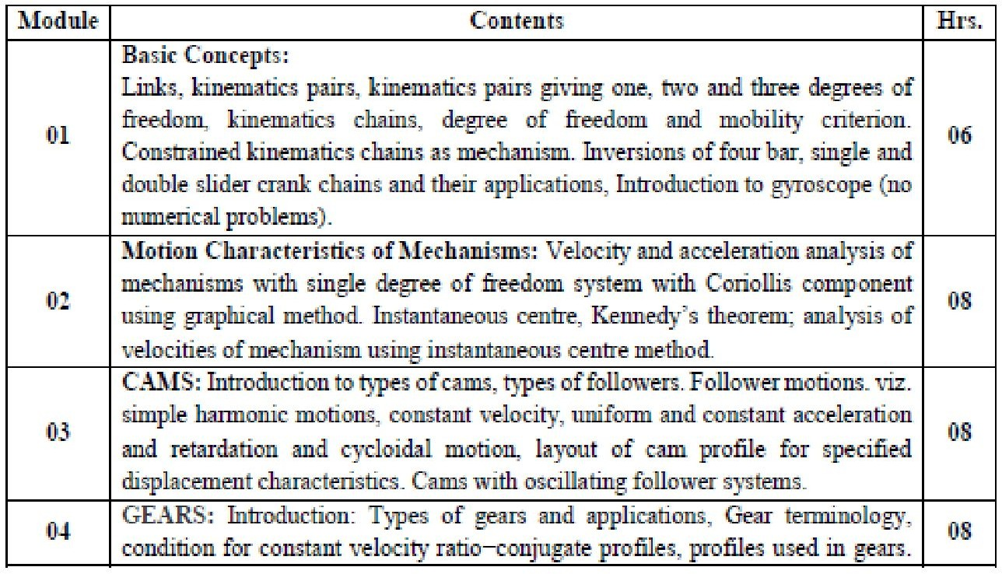

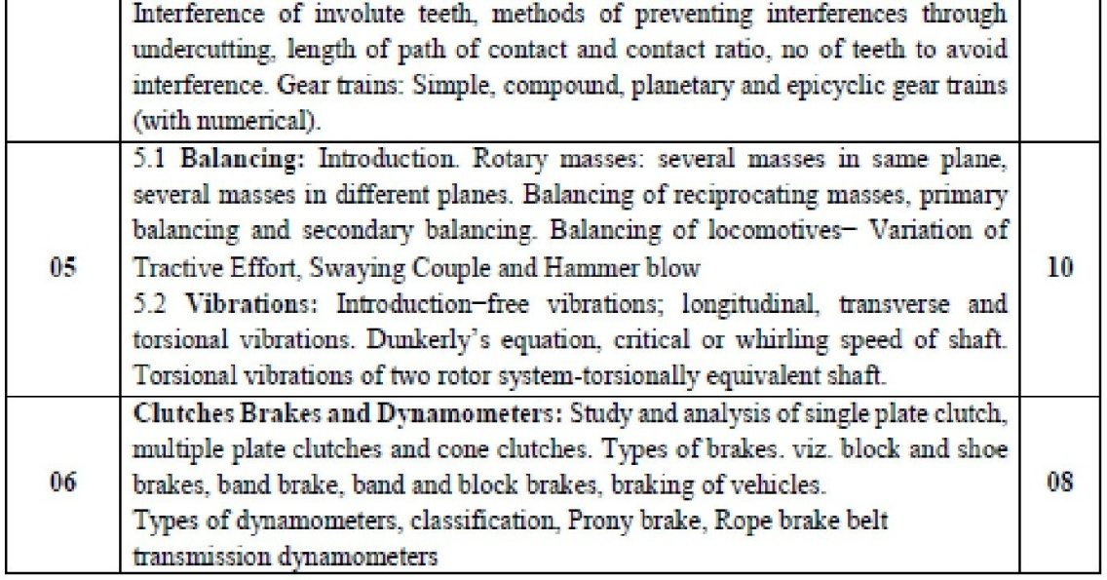

- CO Statements.

Learner will be able to
PEC402.1: Understand the common mechanisms used in machines, correlate the concepts of kinematics with kinetics of rigid body dynamics and Design of four bar mechanisms, gyroscopic devices etc.
PEC402.2: Determine the velocity and acceleration of various links in motion.
PEC402.3: Illustrate different types of cams, followers with their different motions for their application and Develop profiles of cams for engineering applications.
PEC402.4: Illustrate various types of gears/ their terminology areas of application along with parameters pertaining to spur gears and gear trains.
PEC402.5: Develop basic concepts pertaining to balancing/vibrations in evaluation of simple machine components.
PEC402.6: Illustrate different types of clutches, brakes and dynamometers for evaluation of braking force.

CO-PO-PSO Mapping.

CO# / PO# | PO1 | PO2 | PO3 | PO4 | PO5 | PO6 | PO7 | PO8 | PO9 | PO10 | PO11 | PO12
PEC402.1 | 3 | 2 | - | - | - | - | - | - | - | - | - | -
PEC402.2 | 3 | 3 | 2 | - | - | - | - | - | - | - | - | -
PEC402.3 | 3 | 3 | - | - | - | - | - | - | - | - | - | -
PEC402.4 | 3 | 3 | - | - | - | - | - | - | - | - | - | -
PEC402.5 | 3 | 3 | - | - | - | - | - | - | - | - | - | -
PEC402.6 | 3 | 3 | -

CO# / PSO# | PSO1 | PSO2
PEC402.1 | - | -
PEC402.2 | - | -
PEC402.3 | - | -
PEC402.4 | - | -
PEC402.5 | - | -
PEC402.6 | - | -

- CO Assessment tools with target.
Co Statement #
 | Unit Test | End Semester  Exam | Course Exit Survey
PEC402.1 | 50% | 40% | 60%
PEC402.2 | 50% | 40% | 60%
PEC402.3 | 50% | 40% | 60%
PEC402.4 | - | 40% | 60%
PEC402.5 | - | 40% | 60%
PEC402.6 | 40% | 40% | 60%
Target for Assessment Tools

- Curriculum Gap/Content beyond syllabus (if any).

--

- Lecture/Lab/Mini Project/Assignment Plan.

Week No. | Topics | Module | Hours
 | Links, kinematics pairs, kinematics pairs giving one, two and
Week 1 (06/01/2020 – 12/01/2020) | three degrees of freedom, kinematics chains, degree of freedom and mobility criterion. Constrained kinematics chains as mechanism. | 1 | 4
Week 2 (13/01/2020 – 19/01/2020) | Inversions of four bar, single and double slider crank chains and their applications, Introduction to gyroscope (no numerical problems). | 1 | 4
 | Types of brakes. viz. block and shoe brakes, band brake
 | Band and block brakes ,. | 6
Week 3  (20/01/2020 –  26/01/2020) | Types of dynamometers  Prony brake, Rope brake, belt transmission  Introduction to clutches
 |  | 6 | 4
Week 4 (27/01/2020 – 2/02/2020) | Study and analysis of single plate clutch, multiple plate clutches. Study and analysis of cone clutches  braking of vehicles | 3 | 4
Week 5 (3/02/2020 – 9/02/2020) | Introduction to types of cams, types of followers.  Follower motions. viz. simple harmonic motions, constant velocity, uniform and constant acceleration and retardation and cycloidal motion | 3 | 4
Week 6  (10/02/2020 – 16/02/2020) | Layout of cam profile for specified displacement characteristics. Cams with oscillating follower systems. | 3 | 4
Week 7 (17/02/2020 – 23/02/2020) | Euphoria | - | -
Week 8  (24/02/2020 –  1/03/2020) | Unit Test 1 (Feb 26 to 28) – FE, SE, TE.
 |  | - | -
Week 9  (2/03/2020 –  8/03/2020) | Velocity Analysis Analysis of mechanisms with single degree of freedom system using graphical method with Coriollis component using graphical method.
 |  | 2 | 4
Week10 (9/03/2020– 15/03/2020) | Introduction: Types of gears and applications, Gear terminology, condition for constant velocity ratio−conjugate profiles, profiles used in gears. length of path of contact and contact ratio Interference of involute teeth, methods of preventing interferences through undercutting, no of teeth to avoid Interference. | 4 | 3
Week 11 (16/03/2020 – 22/03/2020) | Numericals on Gears  Gear trains: Simple, compound, planetary and epicyclic gear trains (with numerical) | 4 | 4
Week 12 (23/03/2020 – 29/03/2020) | Introduction−free vibrations; longitudinal, transverse and torsional vibrations. Dunkerly’s equation, critical or whirling speed of shaft. Torsional vibrations of two rotor system- torsionally equivalent shaft. | 5 | 3
Week 13  (30/03/2020 –  5/04/2020) | Introduction. Rotary masses: several masses in same plane,  several masses in different planes. Balancing of reciprocating masses, primary balancing and secondary balancing. Balancing of locomotives− Variation of Tractive Effort, Swaying Couple and Hammer blow
 |  | 5 | 4
Week14 (6/04/2020 – 12/04/2020) | Unit Test 2 (April 7 to 9) – SE, TE. | - | -
Week 15 (13/04/2020 – 19/04/2020) | Term End (April 18) | -- | --

Credits-01
FR. Conceicao Rodrigues College Of Engineering
Father Agnel Ashram, Bandstand, Bandra-west, Mumbai-50
Department of Production Engineering

S.E. (Production) (semester IV) (2019-2020)
Lecture Plan
Subject: Dynamics of Machines Laboratory (DOM-PEL401)

Syllabus.

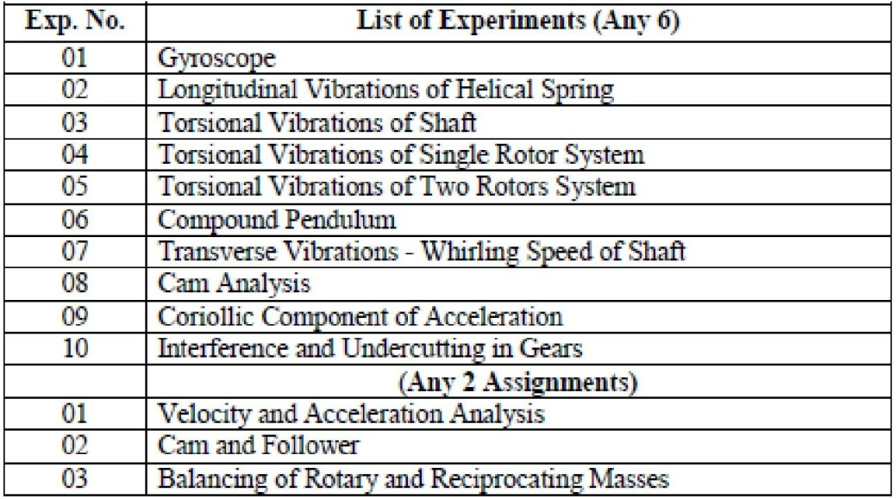

- CO Statements.

Learner will be able to
PEL401.1: Compute the natural frequencies of 1 DOF system. PEL401.2: Apply the working principles of gyroscope and Cam.
PEL401.3: Demonstrate the understanding of static and dynamic balancing. PEL401.4: Compute velocity and acceleration in mechanisms.
PEL401.5: Carryout Cam analysis.
PEL401.6: Demonstrate the practical significance of interference and undercutting in gears.

CO-PO-PSO Mapping.

Laboratory
CO# / PO# | PO1 | PO2 | PO3 | PO4 | PO5 | PO6 | PO7 | PO8 | PO9 | PO10 | PO11 | PO12
PEL401.1 | 3 | 3 | - | - | - | - | - | - | - | - | - | -
PEL401.2 | 3 | 3 | - | - | - | - | - | - | - | - | - | -
PEL401.3 | 3 | 3 | - | - | - | - | - | - | - | - | - | -
PEL401.4 | 3 | 3 | - | - | - | - | - | - | - | - | - | -
PEL401.5 | 3 | 3 | 5 | - | - | - | - | - | - | - | - | -
PEL401.6 | 3 | 3 | -

CO# / PSO# | PSO1 | PSO2
PEL401.1 | - | -
PEL401.2 | - | -
PEL401.3 | - | -
PEL401.4 | - | -
PEL401.5 | - | -
PEL401.6 | - | -

- CO Assessment tools with target.

Co Statement # | Target for Assessment Tools
 | Assignments | Experiments | Oral Exam | Course Exit  Survey
PEL401.1 | - | 70% | 60% | 60%
PEL401.2 | - | 70% | 60% | 60%
PEL401.3 | - | - | 60% | 60%
PEL401.4 | 70% | - | 60% | 60%
PEL401.5 | 70% | 70% | 60% | 60%
PEL401.6 | - | - | 60% | 60%

- Curriculum Gap/Content beyond syllabus (if any).

--

Lab Plan.

Week No. | Topics | Hours (Per  Batch)
Week 3  (20/01/2020 –26/01/2020) | Compound Pendulum | 2
Week 4 (27/01/2020 – 2/02/2020) | Gyroscope | 2
Week 5 (3/02/2020 – 9/02/2020) | Cam and Follower | 2
Week 6  (10/02/2020 – 16/02/2020) | Whirling Speed of Shaft | -
Week 7 (17/02/2020 – 23/02/2020) | Euphoria | 2
Week 8  (24/02/2020 –  1/03/2020) | Unit Test 1 (Feb 26 to 28) – FE, SE, TE. | 2
Week 9  (2/03/2020 –  8/03/2020) | Coriolis Component of Acceleration | 2
Week10 (9/03/2020– 15/03/2020) | Velocity and Acceleration Analysis Assignment | 2
Week 11 (16/03/2020 – 22/03/2020) | Velocity and Acceleration Analysis Assignment | 2
Week 12 (23/03/2020 – 29/03/2020) | Cam and Follower Profile Assignment | 2
Week 13  (30/03/2020 –  5/04/2020) | Cam and Follower Profile Assignment | 2
Week14 (6/04/2020 – 12/04/2020) | Unit Test 2 (April 7 to 9) – SE, TE. | 2
Week 15 (13/04/2020 – 19/04/2020) | Term End (April 18) | --

